**Project Management Plan**

**CSC 331-101**

**Tiffany Huynh, Nathan Tan, Ronald Broughton, Sam Smith, Roddrick Henderson, Trevor Sullivan**

1. **Description of the results to be produced:** The objective of this project is to produce a universal voting platform – Jaguar Secure Voting System (JSVS). It will consist of supporting various contests consisting of multiple candidates. JSVS will allow students to register to vote through a secure system that limits ineligible voters and ballots. Our goal is to create a functional app that will provide students to cast their votes easily on a handheld device.
2. **Work Breakdown Structure:** 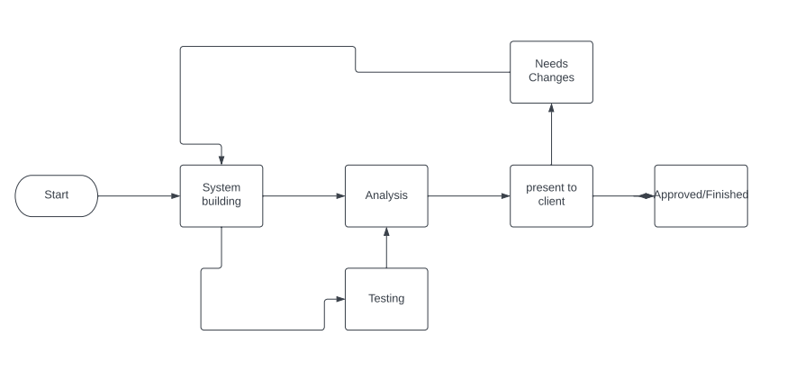

1. **Roles & Responsibilities:**

* Project Manager / Testing: Nathan Tan
  + Organizes the projects processes
  + Communicates with the team to make sure deadlines are met
  + Makes sure proper documentation is in order
  + Keep people on task
* Communication Leader / Testing: Sam Smith, Nathan Tan
  + Communicate with other teams
  + Make sure other teams are on time as well and can make a successful integration with our own part of the project.
* Dev Lead / Testing: Trevor Sullivan
  + Steers the development team towards goals
  + Keeps people in order, schedules tasks to be completed
  + Tests and assists in development
* Front End / Testing: Roddrick Henderson, Sam Smith, Tiffany Huynh
  + In charge of developing the user interface of the application
  + Making a seamless transition between the client and the back end
* Back End / Testing: Trevor Sullivan, Aaron Broughton
  + Making the functionality of the application
  + Securing the application
  + Communicating changes to the front end
* Client: Dr. Yasinsac
  + Give us his goal of the application and help lay out budgets and what he wants

1. **Project Schedule:**

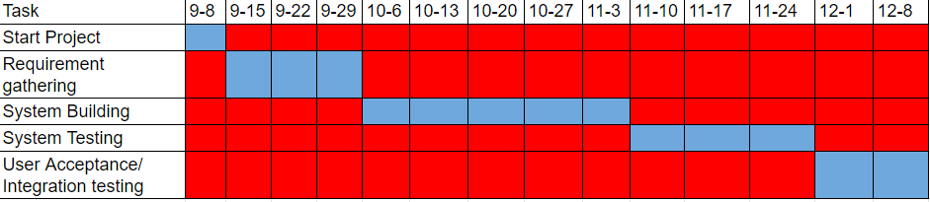

1. **Budget:**

* Identify & review client’s objective
* Determine the client’s budget
* Estimate how long the project will take to complete
* Determine the risks (maintenance, testing), factor out of scope expenses and resources (participants, training, tools)

1. **Management & Identification of Risks:**

| **Risks** | **Affects** | **Probability** | **Solutions** |
| --- | --- | --- | --- |
| * Team members contract COVID/sick. * Team member drops class. * Inadequate project management * Low productivity * Coding/technical issues/ * Conflicting meeting times with client & development team * Inaccurate estimations/expectations | Team  Team  Client / Team  Project  Project  Business / Product  Product / Business | High  Moderate  Moderate-high  High  High  Low  Moderate | * Other team members will have to pick up extra work temporarily * Other team members will have to pick up extra work permanently * Delegate a new project manager * Change how we manage our time * Make sure we’re doing adequate research * Be considerate of others time * Reassess project specs, requirements, & issues |